**Arduino UNO Data Sheet**

* <https://www.arduino.cc/en/Main/ArduinoBoardUno>

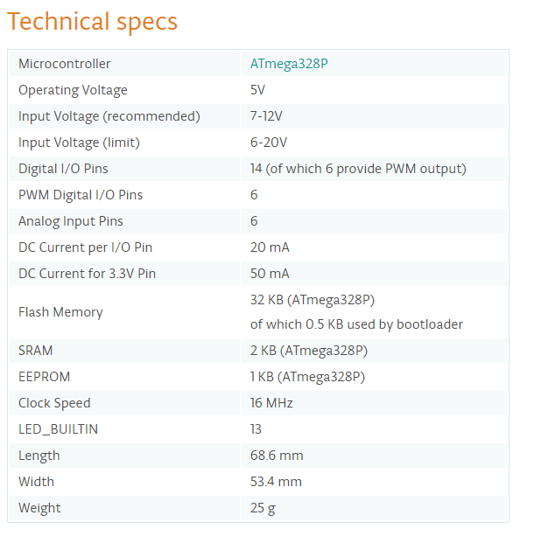

**MOSFET Data Sheet**

* <http://elcodis.com/parts/404685/IRFZ44NPBF.html>

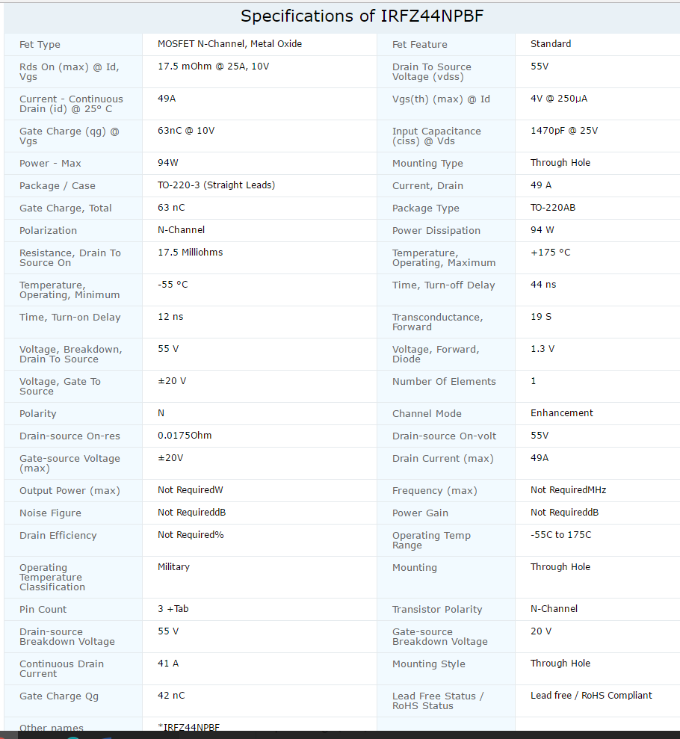

**Telma Eddy Current Absorber Data Sheet**

* <http://www.telmausa.com/Downloads/OC442066.pdf>

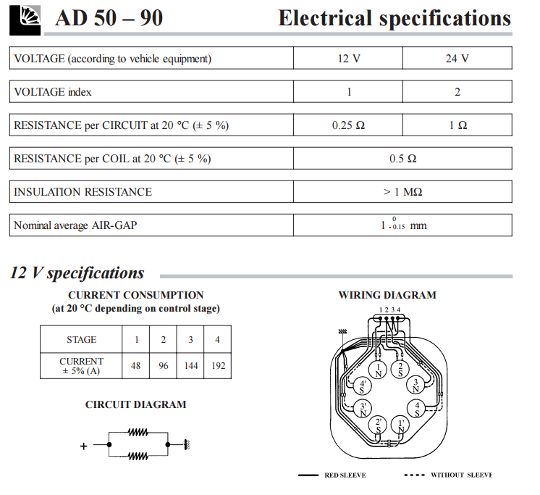

**51R 60 12V Battery Data Sheet**

* <http://datasheets.globalspec.com/ds/961/ContinentalBatteries/969F8F86-DF26-4D48-B83A-FF807F713D5C>

